  
  
  
  
CS 319 - Object-Oriented Software Engineering  
Analysis Report

Nightmare Dungeon  
Group 2-C  
Mehmet Oğuz Göçmen

Berk Mandıracıoğlu

Hakan Sarp Aydemir

Hüseyin Emre Başar

Table of Contents

1. Introduction ................................................................................................................................ 5

2. Game Overview .......................................................................................................................... 6

2.1. Gameplay ..................................................................................................................... 6

2.2. Levels ........................................................................................................................... 7

2.3. List of Items & Power-ups ........................................................................................... 7

3. Requirements ............................................................................................................................ 10

3.1. Functional Requirements ........................................................................................... 10

3.2. Non-Functional Requirements ................................................................................... 10

3.3. Pseudo Functional Requirements .............................................................................. 11

4. System Models ......................................................................................................................... 12

4.1. Use Case Model ......................................................................................................... 12

4.1.1. Use Case Descriptions ................................................................................ 12

4.1.1.1. Play Game .................................................................................... 12

4.1.1.2. View Help .................................................................................... 14

4.1.1.3. View High scores ......................................................................... 14

4.1.1.4. View Credits ................................................................................ 15

4.1.1.5. Pause Game ................................................................................. 15

4.1.1.6. Quit Game ................................................................................... 16

4.1.1.7. Change Settings ........................................................................... 16

4.1.1.8. Continue Game ............................................................................ 17

4.1.1.9. Change Music Volume ................................................................ 17

4.1.1.10. Change Interaction Volume ....................................................... 17

4.1.1.11. Have Different Upgrades ........................................................... 18

4.1.1.12. Have Different Mobs.................................................................. 18

4.1.1.13. Have Different Levels ................................................................ 19

4.2. Dynamic Models ........................................................................................................ 20

4.2.1. Sequence Diagrams .................................................................................... 20

4.2.2. Activity Diagram ........................................................................................ 25

4.3. Object and Class Model ............................................................................................. 27

4.4. User Interface – Navigational Paths and Screen Mock-ups ...................................... 29

4.4.1. Navigational Paths ...................................................................................... 29

4.4.2. Mock-ups .................................................................................................... 30

5. References ................................................................................................................................ 38

Table of Figures

Figure 4.1.1. - Use Case Diagram of the System .......................................................................... 12

Figure 4.2.1.1. - Sequence Diagram of Change Settings Scenario ............................................... 20

Figure 4.2.1.2. - Sequence Diagram of Move Player Scenario .................................................... 21

Figure 4.2.1.3. - Sequence Diagram of Player Attack Scenario ................................................... 22

Figure 4.2.1.4. - Sequence Diagram of Monster Attack Scenario ................................................ 23

Figure 4.2.1.5. - Sequence Diagram of Monster Move Scenario ................................................. 24

Figure 4.2.2.1. Activity Diagram of the System ........................................................................... 25

Figure 4.3.1. Class Diagram of the System................................................................................... 27

Figure 4.4.1.1. Navigational Path of the game ............................................................................. 29

Figure 4.4.2.1. Mock-up of the Main Menu frame ....................................................................... 30

Figure 4.4.2.2. Mock-up of game itself ........................................................................................ 31

Figure 4.4.2.3. Mock-up of Settings Frame .................................................................................. 32

Figure 4.4.2.4. Mock-up of High Scores Frame ........................................................................... 33

Figure 4.4.2.5.1 Mock-up of Help frame which includes Controls .............................................. 34

Figure 4.4.2.5.2 Mock-up of Help frame which includes Gameplay ........................................... 35

Figure 4.4.2.6. Mock-up of Credits Frame ................................................................................... 36

Figure 4.4.2.7. Mock-up of In-Game Menu Frame ...................................................................... 37

**4.2.2. Activity Diagram**

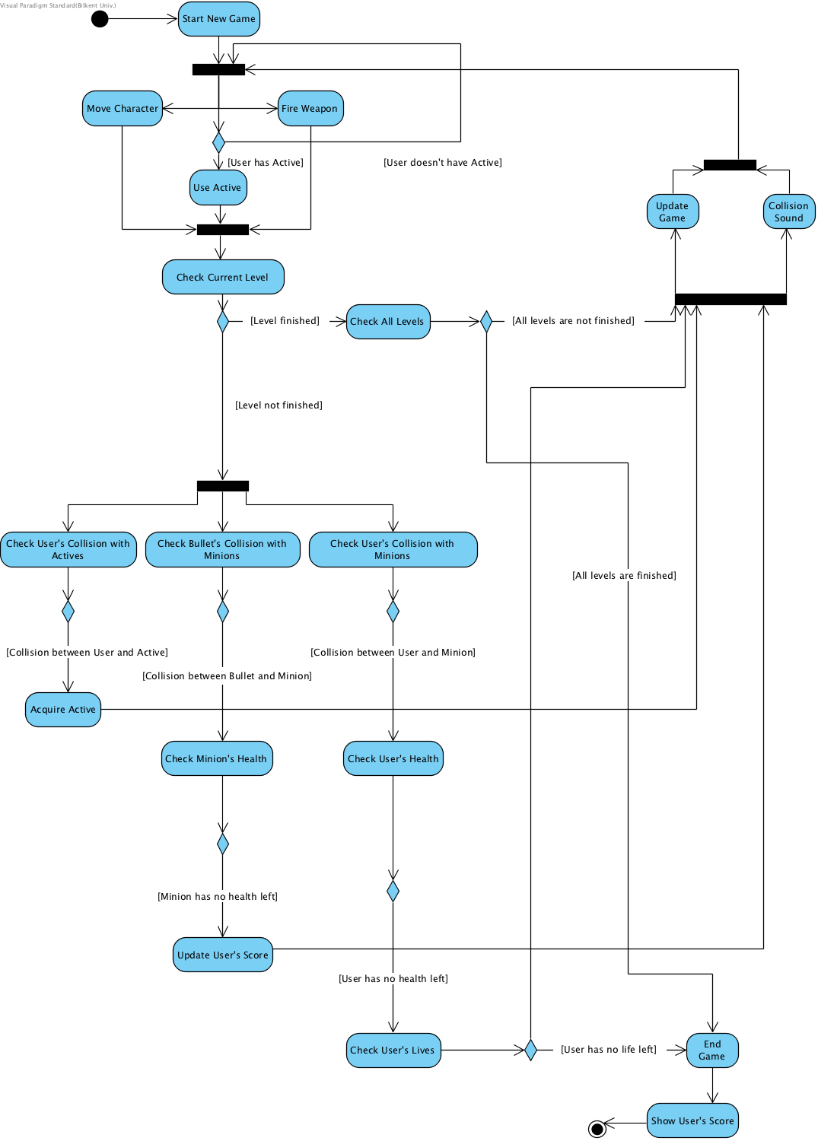This diagram shows how system maintains gameplay.

**Figure 4.2.2.1. Activity Diagram of the System**

Activity diagram given in figure 4.2.2.1 shows the main flow in game. Each time user presses “Play button”, game starts running and relevant components (map, user character, minions, obstacles, stat indicators etc.) are rendered to frame. After the process finishes, listeners will listen to keystrokes of user which will indicate whether user pressed movement keys, firing keys and active power keys. Additionally, if user presses active power key, game will check whether user has active power or not and act accordingly.

When a keystroke is detected, system will check if current level is proceeding or it’s over. If current level is over, system will check all levels for completeness. If all levels are completed, game will be over, else game will proceed and objects will be updated. If current level is not over, system will check interactions between main objects simultaneously. 3 processes will be checked concurrently.

System will check the collision between the user and active powers which will appear in map randomly. If collision is detected, user will be awarded with an active power.

System will check the collision between the bullets that user fires and minion. If collision is detected, system will check whether minion has health or not. If minion has no health, user will gain more score and update the score.

System will check the collision between user and minion. If collision is detected, user’s health will be checked. If user has no health left, user’s lives will be checked. If user has no life left to play, game will end. Otherwise user will start the map again.

In all other cases, game will update itself every time and collision sounds will be given. When user’s lives are ended or all levels are finished, game will end and system will show user’s score.

**4.4. User Interface – Navigational Paths and Screen Mock-ups**

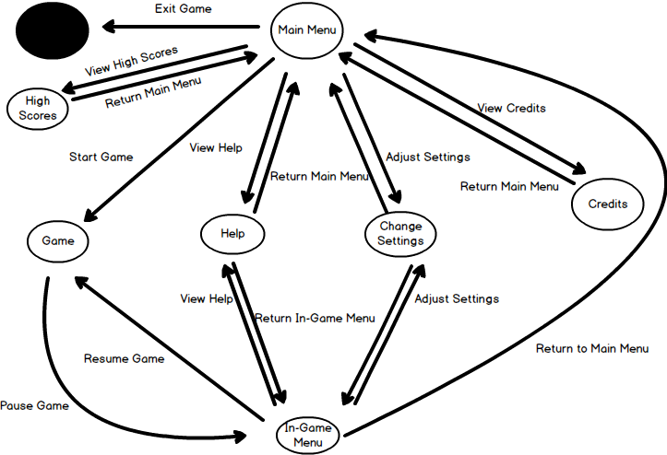**4.4.1. Navigational Paths**

**Figure 4.4.1.1. Navigational Path of the game**

**4.4.2. Mockups**

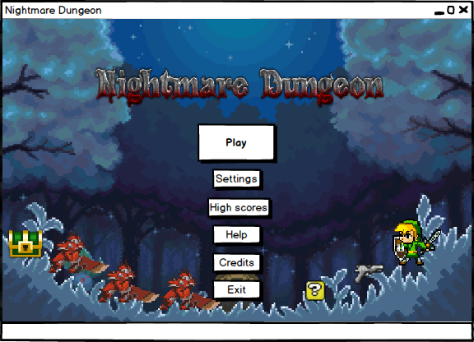**Main menu:** When application starts running, user will encounter the Main Menu frame in which there will be 5 buttons to press. This buttons are: Play, Settings, Help, Credits, Exit. Mockup of the Main Menu frame is given in fıgure 4.4.2.1.

**Figure 4.4.2.1. Mockup of the Main Menu frame**

**Play:** Play button will signal game to start with default settings from the first level. Mockup of the game itself is given in figure 4.4.2.2.

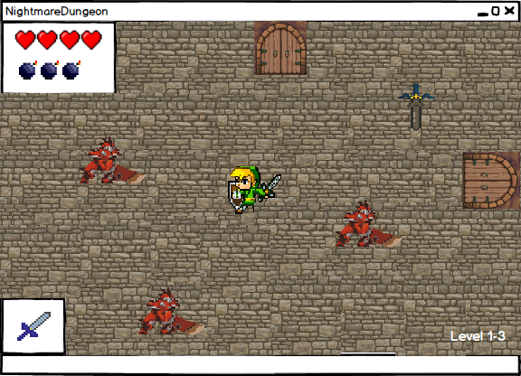

**Figure 4.4.2.2. Mockup of game itself**

**Settings:** Settings button will enable the transition to settings frame. This frame includes some optional settings relevant to gameplay. User will be able to turn on/off in-game effect sounds, music sound etc. This settings frame will also be available in in-game menu in case of an unpleasant experience of the game. Mockup of the Settings frame is given in figure 4.4.2.3.

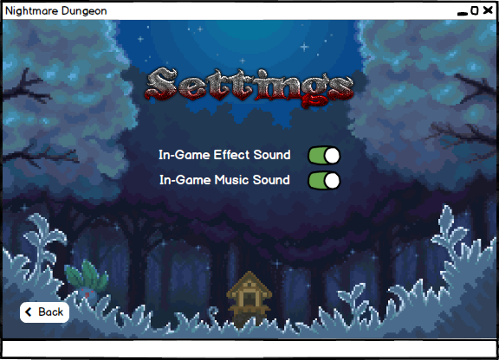

**Figure 4.4.2.3. Mockup of Settings Frame**

**High Scores:** High Scores will open the High Scores Frame which will display the first 10 scores of the game. If player gets a score in this span, user’s score will be added to this frame.

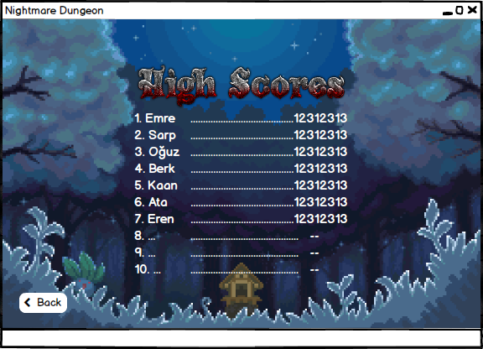

**Figure 4.4.2.4. Mockup of High Scores Frame**

**Help:** Help button will open the Help frame which includes the controls of the game, and upgrades that will come throughout the game. Controls include “WASD” keys to move, arrow keys to fire at minions. Gameplay will include relevant information about the game (not all of them!!!). Help frame will have buttons called “gameplay” and “controls” which will enable to transition within each other incase user wants to see them again before starting. There will also be back button to go back to menu. Mockups of the Help frames are given in figure 4.4.2.4.1 and 4.4.2.4.2.

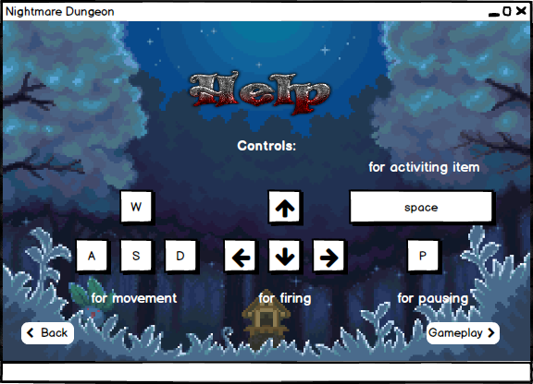

**Figure 4.4.2.5.1 Mockup of Help frame which includes Controls**

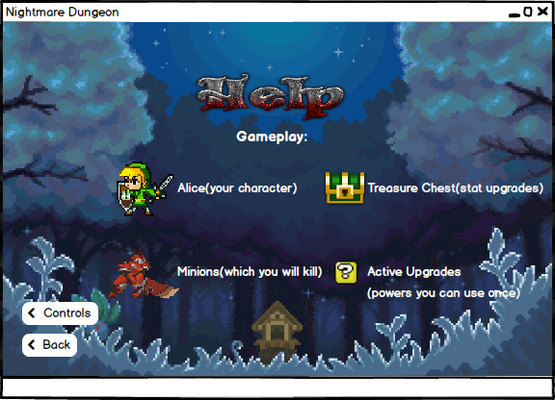

**Figure 4.4.2.5.2 Mockup of Help frame which includes Gameplay**

**Credits:** Credits button will open the Credits frame to show user the makers of the game. Back button will enable to go back to menu. Mockup of the Credits frame is given in figure 4.4.2.5.

**Exit:** Exit button is to shut down the game.

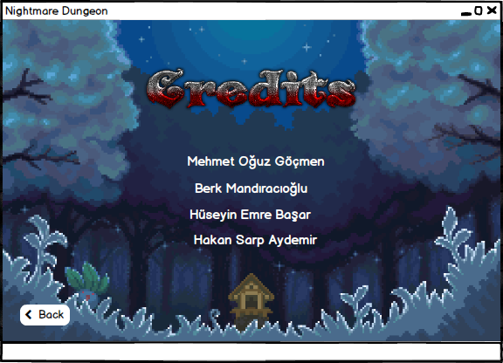

**Figure 4.4.2.6. Mock-up of Credits Frame**

**In-Game Menu:** Throughout the game, user will be able to pause the game and resume later by pressing P key. When user presses the key, in-game pause menu will appear as an overlay. This menu will include 4 buttons: Resume, Settings, Help, Return to Main Menu. Resume button will resume the game from the moment it had been paused. Settings and Help button will bring up the frames Settings and Help whose mockups are given before in figures …. Return to Main Menu button will direct the user to Main Menu and the progress of the game will 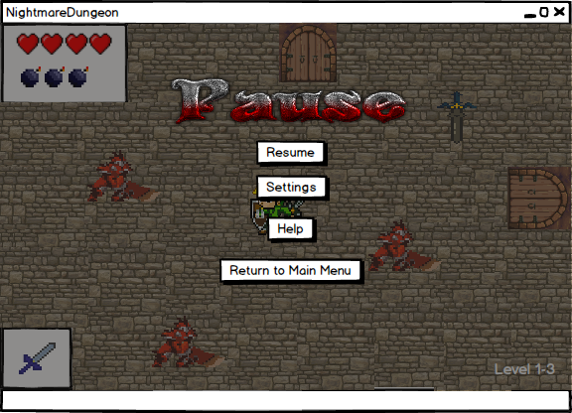be lost as well. Mockup of In-Game Menu is given in figure 4.4.2.7.

**Figure 4.4.2.7. Mock-up of In-Game Menu Frame**